Cape Peninsula University of Technology
Faculty of Informatics & Design · Department of Information Technology
PRJ470S – Projects 4: Advanced Diploma in ICT (Applications Development)
Assessment Four: Research Report
THE ADOPTION OF CLOUD COMPUTING BY SMALL TO MEDIUM ENTERPRISES IN SOUTH AFRICA
A systematic literature review through the Technology-Organisation-Environment (TOE) lens
Item | Detail
Student | Thabiso Patrick Matsaba
Student number | 220296006
Qualification | Advanced Diploma in ICT (Applications Development)
Supervisor | Dr Kenneth Ohei
Research design | Qualitative systematic literature review (PRISMA 2020)
Submission | October 2026

Plagiarism Declaration and AI Disclosure
I, Thabiso Patrick Matsaba, declare that this research report is my own work. I am aware of the Cape Peninsula University of Technology (CPUT) Policy on Plagiarism and Academic Dishonesty. All sources used have been acknowledged through in-text citations and a reference list in the CPUT Harvard style. No part of this report has been submitted for a qualification at this or any other institution.
Disclosure of generative AI use. In line with the CPUT Student Practice Guide for Generative AI, the use of AI tools in preparing this report is disclosed below.
Question | Disclosure
Was generative AI used? | [X] YES / [ ] NO. Tools: Gemini NotebookLM; Claude (Anthropic).
Scope of use | Gemini: editing of sentence flow, spelling and grammar. Claude: restructuring the report into the research-report format, drafting and redrafting prose in the methodology, findings, discussion and conclusion chapters from my extraction notes, and generating the charts and the PRISMA diagram from my literature tracker data.
Researcher responsibility | I defined the topic, research questions, TOE lens, search strategy and inclusion criteria, collected and screened the articles, and verified every citation and page number against the source PDFs. I take responsibility for all content.

Candidate signature: _______________________ Date: ____________________

Abstract
Small and medium enterprises (SMEs) are central to South Africa's economy, yet many continue to rely on traditional, on-premises information technology rather than cloud computing. This study examined the technological, organisational and environmental factors that influence cloud computing adoption by South African SMEs, and proposed a contextualised adoption framework. A qualitative systematic literature review was conducted following the PRISMA 2020 statement. Eight databases were searched and 342 records were identified; after screening, eligibility assessment, quality appraisal with the Mixed Methods Appraisal Tool and evidence verification, 18 studies published between 2014 and 2025 were included. The included studies were described by year, source database, publication channel, research method and geographic focus, and their findings were analysed through thematic synthesis anchored in the Technology-Organisation-Environment (TOE) framework.
The review found that security and privacy concerns and infrastructure constraints were discussed in almost every study (17 of 18), followed by relative advantage and government or regulatory support (14 of 18 each). Relative advantage was the most consistent enabler, but its effect depended on owner-manager awareness. Evidence on top management support diverged: it was a leading driver in international reviews but was not significant in a South African survey. Uncertainty about how the Protection of Personal Information Act applies to cloud services, weak government support and unreliable infrastructure acted as the main South African constraints, while direct evidence on electricity reliability was scarce. The study proposes a contextualised TOE framework that adds a South African context layer to the three standard contexts and links each context to a practical response.
Keywords: cloud computing; small and medium enterprises; South Africa; TOE framework; systematic literature review; POPIA

Table of Contents
Plagiarism Declaration and AI Disclosure 1
Abstract 1
Table of Contents 1
List of Figures and Tables 1
Chapter 1: Introduction 1
1.1 Introduction 1
1.2 Background to the Research Problem 1
1.3 Research Problem 1
1.4 Aim and Objectives 1
1.5 Research Questions 1
1.6 Delineation of the Study 1
1.7 Structure of the Report 1
Chapter 2: Literature Review 1
2.1 Introduction 1
2.2 Cloud Computing Service and Deployment Models 1
2.3 The Technology-Organisation-Environment (TOE) Framework 1
2.4 Technological Factors 1
2.5 Organisational Factors 1
2.6 Environmental Factors 1
2.7 Research Gap 1
Chapter 3: Research Methodology 1
3.1 Introduction 1
3.2 Research Philosophy and Approach 1
3.3 Research Design: Systematic Literature Review 1
3.4 Data Sources and Search Strategy 1
3.5 Inclusion and Exclusion Criteria 1
3.6 Study Selection Process 1
3.7 Quality Appraisal 1
3.8 Data Extraction 1
3.9 Data Analysis 1
3.10 Rigour 1
3.11 Ethical Considerations 1
Chapter 4: Findings and Discussion 1
4.1 Introduction 1
4.2 Key Publication Attributes of the Included Studies 1
4.2.1 Publication representation by year 1
4.2.2 Publication representation by database 1
4.2.3 Publication representation by channel 1
4.2.4 Publication representation by research method 1
4.2.5 Publication representation by geographic focus 1
4.2.6 Coverage of TOE factors 1
4.3 Thematic Analysis 1
4.3.1 Research Question 1: Technological Factors 1
Theme 1.1: Perceived value and relative advantage 1
Theme 1.2: Security, privacy and data sovereignty 1
Theme 1.3: Complexity and compatibility 1
4.3.2 Research Question 2: Organisational Factors 1
Theme 2.1: Owner-manager and top management support 1
Theme 2.2: Skills and IT expertise 1
Theme 2.3: Readiness and financial capacity 1
4.3.3 Research Question 3: Environmental Factors 1
Theme 3.1: Competitive pressure 1
Theme 3.2: Government and regulatory support 1
Theme 3.3: Infrastructure and power reliability 1
4.3.4 Research Question 4: A Contextualised Framework 1
4.4 Discussion of Findings Against the Literature 1
Chapter 5: Conclusion and Recommendations 1
5.1 Summary of the Study 1
5.2 Answers to the Research Questions 1
5.3 Recommendations 1
5.4 Contribution of the Study 1
5.5 Limitations 1
5.6 Future Research 1
References 1
Appendix A: Data Extraction Summary 1
Appendix B: MMAT Quality Appraisal 1
Appendix C: Database Search Strings 1

Right-click the table and choose "Update Field" to refresh page numbers.

List of Figures and Tables
- Figure 3.1: PRISMA 2020 flow diagram of the study selection process
- Figure 4.1: Distribution of included studies by publication year
- Figure 4.2: Distribution of included studies by source database
- Figure 4.3: Distribution of included studies by publication channel
- Figure 4.4: Distribution of included studies by research method
- Figure 4.5: Distribution of included studies by geographic focus
- Figure 4.6: Frequency of TOE factors across the included studies
- Figure 4.7: Proposed contextualised TOE framework for South African SMEs
- Table 3.1: Inclusion and exclusion criteria
- Table 3.2: Search results by database
- Table 4.1: Summary of included studies
- Table 4.2: TOE context coverage by study
- Table 4.3: Research questions, objectives and emergent themes
- Table 4.4: Contextualised TOE framework matrix

Chapter 1: Introduction

1.1 Introduction
Technology has changed how modern enterprises operate, and the move to cloud computing is one of the most significant parts of that change. Cloud computing allows organisations to run applications, manage business systems and store information over the internet without investing in expensive physical hardware. SMEs can therefore obtain IT services without recurrent maintenance, retraining or high upfront cost, on a pay-per-use basis through three service models: Software-as-a-Service (SaaS), Platform-as-a-Service (PaaS) and Infrastructure-as-a-Service (IaaS) (Jayeola et al., 2022:227–228; Ahmad et al., 2025:2). The National Institute of Standards and Technology defines cloud computing as a model for enabling ubiquitous, convenient, on-demand network access to a shared pool of configurable computing resources that can be rapidly provisioned and released with minimal management effort (Mell & Grance, 2011:2).
SMEs are the backbone of the South African economy. They contribute substantially to employment and gross domestic product, and the National Development Plan expects them to generate most new jobs by 2030 (Sithole & Ruhode, 2021:282–283). For resource-constrained firms, the cloud offers cost savings and scalability (Ilahi et al., 2024:57) and tools that improve efficiency, agility and competitiveness (Mkhize et al., 2025:2). Despite these benefits, South African SMEs continue to rely on traditional IT services, and limited knowledge and security concerns hold adoption back (Mokwena & Fatoki, 2024:4625, 4628). SMEs in Africa more broadly face limited internet infrastructure, cybersecurity risks and a lack of digital skills (Mhlongo et al., 2024:1445).
Understanding why adoption remains limited requires a lens that goes beyond technical features. This study used the Technology-Organisation-Environment (TOE) framework of Tornatzky and Fleischer (1990) to identify and categorise the factors that influence adoption decisions, because the framework considers the technology, the adopting firm and its external environment together (Sithole & Ruhode, 2021:285).

1.2 Background to the Research Problem
South Africa has one of the most advanced ICT infrastructures in Africa, yet broadband penetration remains limited in rural areas and many SMEs lack the technical resources and awareness needed to adopt cloud services (Mhlongo et al., 2024:1446). SMMEs face a range of challenges that lead to failure or stagnation (Sithole & Ruhode, 2021:282–283), and the non-availability of financial and IT resources is among the causes of their high failure rate (Mokwena & Fatoki, 2024:4625).
Moving to the cloud also raises regulatory questions that are specific to South Africa. There is no dedicated legislative framework for cloud computing, and there is a lack of clarity about how the Protection of Personal Information (POPI) Act applies to cross-border transfers of data held by cloud providers; some of its provisions only partly apply (Mohlameane & Ruxwana, 2020:5–7). Unreliable electricity is a further concern for African SMEs, although cloud services can also reduce reliance on electricity-hungry on-premises hardware (Abubakar et al., 2014:7, 10).

1.3 Research Problem
South African small and medium enterprises are not adopting cloud computing at a rate commensurate with its potential to improve their operations, and the combined technological, organisational and environmental factors inhibiting this transition have not been comprehensively examined through an integrated, locally relevant theoretical framework.

1.4 Aim and Objectives
The aim of the study was to investigate the technological, organisational and environmental factors that influence cloud computing adoption among South African SMEs, using the TOE framework as an analytical lens, and to propose a contextualised adoption framework. The objectives were:
- To identify the technological factors that hinder or enable cloud computing adoption among South African SMEs.
- To examine the organisational factors that influence cloud computing adoption decisions among South African SMEs.
- To examine the environmental factors that shape SME decisions to adopt or avoid cloud-based systems in South Africa.
- To propose a framework that can guide South African SMEs in making informed and sustainable cloud adoption decisions.

1.5 Research Questions
Main research question: What are the key technological, organisational and environmental factors that influence cloud computing adoption among small and medium enterprises in South Africa, and how can these factors be addressed through a contextualised adoption framework?
The main question was answered through four sub-questions, each aligned with one objective:
Sub-question | Aligned objective | TOE context
RQ1: What technological factors hinder or enable cloud computing adoption among South African SMEs? | Objective 1 | Technological
RQ2: What organisational factors influence the cloud computing adoption decisions of South African SMEs? | Objective 2 | Organisational
RQ3: What environmental factors shape SME decisions to adopt or avoid cloud-based systems in South Africa? | Objective 3 | Environmental
RQ4: How can a TOE-informed framework guide South African SMEs to adopt cloud computing in an affordable, compliant and operationally appropriate way? | Objective 4 | All three

1.6 Delineation of the Study
The study was limited to published research on formal SMEs, defined under the National Small Business Act (Act 102 of 1996, as amended) as enterprises with fewer than 200 employees. It focused on factors relevant to the South African environment, including POPIA and infrastructure reliability, and drew comparative evidence from other developing and emerging economies. It covered the SaaS, PaaS and IaaS service models and the public, private and hybrid deployment models. No primary data were collected.

1.7 Structure of the Report
Chapter 2 reviews the literature on cloud computing and the TOE framework. Chapter 3 describes the systematic review methodology, including the PRISMA selection process. Chapter 4 presents the findings and discussion: first a description of the included studies, then a thematic analysis organised by research question. Chapter 5 concludes the report with recommendations, limitations and directions for future research.

Chapter 2: Literature Review

2.1 Introduction
This chapter reviews the literature on cloud computing adoption by SMEs, with emphasis on South Africa. It is structured around the three contexts of the TOE framework, and it closes by identifying the gap the study addressed.

2.2 Cloud Computing Service and Deployment Models
Cloud computing has five essential characteristics: on-demand self-service, broad network access, resource pooling, rapid elasticity and measured service (Mell & Grance, 2011:2). Capabilities are delivered through three service models (Ahmad et al., 2025:2; Jayeola et al., 2022:228). With SaaS, the SME uses the provider's applications through a browser and manages none of the underlying infrastructure, which makes it the most accessible option for firms with limited IT skills. PaaS gives the SME an environment for deploying its own applications while the provider manages the infrastructure. IaaS supplies virtual machines, storage and networks on a pay-as-you-go basis, but leaves the operating systems and applications to the SME, which requires advanced in-house expertise.
Cloud services are deployed as public, private, community or hybrid clouds (Mokwena & Fatoki, 2024:4627). Public clouds are the most cost-effective but offer least control over where data are stored; private clouds offer control at high cost; hybrid clouds combine the two, allowing non-sensitive workloads to run in a public cloud while sensitive data stay under closer control.

2.3 The Technology-Organisation-Environment (TOE) Framework
The TOE framework proposes that the adoption of a technological innovation is shaped by three interacting contexts: the technological context (characteristics of the technology), the organisational context (characteristics and resources of the firm) and the environmental context (the industry, competitors and government) (Tornatzky & Fleischer, 1990; Sithole & Ruhode, 2021:285). Unlike the Technology Acceptance Model, which focuses on individual users' perceptions (Davis, 1989), the TOE framework operates at firm level. It is widely used in cloud adoption research, where relative advantage, top management support, technical readiness and competitive pressure are the most frequently reported determinants (Ilahi et al., 2024:55).

2.4 Technological Factors
Relative advantage is the degree to which cloud computing is perceived as better than existing IT. It is repeatedly identified as a driver of adoption (Aligarh et al., 2023:1; Ilahi et al., 2024:58), and cost savings are the most important adoption factor across a decade of SME studies (Jayeola et al., 2022:226). Compatibility with existing systems and complexity also matter: compatibility was significant in 79.3% of the studies reviewed by Jayeola et al. (2022:239), and complexity and security were significant in Lebanese SMEs (Skafi et al., 2020:79169). Security and privacy are the most researched factors in this field (Jayeola et al., 2022:234).

2.5 Organisational Factors
Top management support was significant in 82.1% of the studies reviewed by Jayeola et al. (2022:239) and cited as a driver in 68% of those reviewed by Mkhize et al. (2025:1). In SMEs, where decisions are concentrated in the owner-manager, awareness at the top is decisive (Abubakar et al., 2014:9). Skills and prior IT experience are also important: insufficient top management support and lack of IT experience are listed among the main obstacles (Mkhize et al., 2025:2), and digital literacy and technical skills are lacking among African SMEs (Mhlongo et al., 2024:1446). Readiness and cost complete the organisational context: initial cost concerns affected 48% of the SMEs in reviewed studies (Mkhize et al., 2025:1).

2.6 Environmental Factors
Competitive pressure pushes firms to adopt cloud services to keep pace with rivals (Aligarh et al., 2023:1; Ilahi et al., 2024:55). Government and regulatory support can enable or inhibit adoption; in South Africa it was perceived as a barrier (Sithole & Ruhode, 2021:282), and existing legislation fits cloud computing only partly (Mohlameane & Ruxwana, 2020:7). Infrastructure is a contextual factor that global models often take for granted: poor infrastructure and a lack of government initiatives were negatively related to adoption in Lebanon (Skafi et al., 2020:79169), and limited broadband restricts adoption across Africa (Mhlongo et al., 2024:1446).

2.7 Research Gap
Most TOE-based studies of SME cloud adoption were conducted in Asia and the Middle East, and Asia records the highest number of studies (Jayeola et al., 2022:226). These studies generally assume stable infrastructure and do not consider South African regulation. South African research examines regulation (Mohlameane & Ruxwana, 2020), barriers (Mokwena & Fatoki, 2024) and TOE factors (Sithole & Ruhode, 2021) separately. No study has synthesised this evidence into a contextualised framework for South African SMEs. This review addressed that gap.

Chapter 3: Research Methodology

3.1 Introduction
This chapter describes how the study was conducted. The researcher adopted a qualitative systematic literature review (SLR) and followed the PRISMA 2020 reporting guideline (Page et al., 2021). The chapter explains the research philosophy and approach, the data sources and search strategy, the inclusion and exclusion criteria, the selection process, quality appraisal, data extraction and analysis, and ethical considerations.

3.2 Research Philosophy and Approach
The study adopted an interpretivist philosophy. Cloud adoption was treated as a socio-technical process in which technology interacts with the resources of the firm and its environment, and the reasons for adoption decisions were interpreted from the findings reported in published studies. The researcher adopted a qualitative approach because the aim was to understand factors, perceptions and contextual conditions rather than to produce new statistical measurements. Reported findings and authors' interpretations were treated as textual data (Thomas & Harden, 2008).

3.3 Research Design: Systematic Literature Review
An SLR was chosen because primary surveys of cloud adoption in South Africa tend to cover a single municipality or sector, whereas a systematic review allows evidence from separate studies, regions and sectors to be identified, appraised and combined in a transparent and repeatable manner (Tranfield et al., 2003; Jayeola et al., 2022:226). The review followed three PRISMA stages: identification, screening and inclusion.

3.4 Data Sources and Search Strategy
The researcher searched eight electronic databases on 15 August 2026: Scopus, Web of Science, IEEE Xplore, ACM Digital Library, ScienceDirect, SpringerLink, Google Scholar and MDPI. The databases were selected to cover information systems, computing and business research. The core Boolean search string applied to titles, abstracts and keywords was:
("cloud computing adoption" OR "cloud adoption") AND ("SMEs" OR "small and medium enterprises" OR "SMMEs" OR "small businesses") AND ("Technology Organisation Environment" OR "TOE framework") AND ("South Africa" OR "developing economy" OR "developing nations")
The string was adapted to the syntax of each database (Appendix C), with filters for English-language, peer-reviewed publications from 2020 to 2026. In addition, the researcher searched the reference lists of included reviews (backward citation searching) to identify foundational studies on SMEs in developing economies. Table 3.2 shows the results per database.
Table 3.2: Search results by database
Database | Records identified | Duplicates removed | Records screened | Excluded (title/abstract) | Full texts assessed
Scopus | 45 | 10 | 35 | 20 | 15
Web of Science | 22 | 8 | 14 | 8 | 6
IEEE Xplore | 18 | 5 | 13 | 7 | 6
ACM Digital Library | 12 | 2 | 10 | 6 | 4
ScienceDirect | 38 | 15 | 23 | 12 | 11
SpringerLink | 25 | 12 | 13 | 8 | 5
Google Scholar | 150 | 45 | 105 | 85 | 20
MDPI | 32 | 5 | 27 | 18 | 9
Total | 342 | 102 | 240 | 164 | 76

Source: PRISMA search log, cloud_adoption_lit_tracker_v2.xlsx

3.5 Inclusion and Exclusion Criteria
The researcher applied the criteria in Table 3.1. Studies published from 2020 onwards were targeted so that the findings reflect current conditions, including the full enforcement of POPIA from July 2021. Four earlier studies (2014–2018) identified through citation searching were retained because they provide foundational evidence on SMEs in developing economies and sub-Saharan Africa that later studies build on.
Table 3.1: Inclusion and exclusion criteria
Criterion | Inclusion | Exclusion
Publication date | 2020–2026 for database searches; earlier foundational studies via citation searching | Pre-2020 records returned by database searches
Language | English | Non-English
Publication type | Peer-reviewed journal articles and conference papers | Editorials, blogs, news, opinion pieces, non-peer-reviewed reports
Topic | Cloud computing adoption by SMEs, using or discussing TOE factors | Non-cloud ICT, large enterprises only, unrelated IS models
Context | South Africa and comparable developing or emerging economies; global SME reviews | Single-country studies of high-income markets (e.g. USA, UK, Japan)
Access | Full text available to the researcher | Full text not available

3.6 Study Selection Process
Selection followed the PRISMA 2020 flow shown in Figure 3.1. The database search identified 342 records, and 102 duplicates were removed. The researcher screened the titles and abstracts of the remaining 240 records and excluded 164 that did not address SME cloud adoption. The full texts of 76 reports were assessed against the eligibility criteria, and 46 were excluded because they were published before 2020, focused on large enterprises, did not address cloud computing or TOE factors, studied high-income markets, or were not peer-reviewed. Thirty reports passed full-text assessment and quality appraisal.
At the data-extraction stage each of the 30 records was checked against its PDF. Sixteen were removed because the full text was not retained in the evidence folder or the retrieved file did not match the recorded study. Fourteen database studies were therefore retained. Together with four studies identified through citation searching, 18 studies were included in the synthesis. The drop from 30 to 18 shows why the number assessed for eligibility is not the final inclusion number: every study used in the analysis had to be verified against its source.
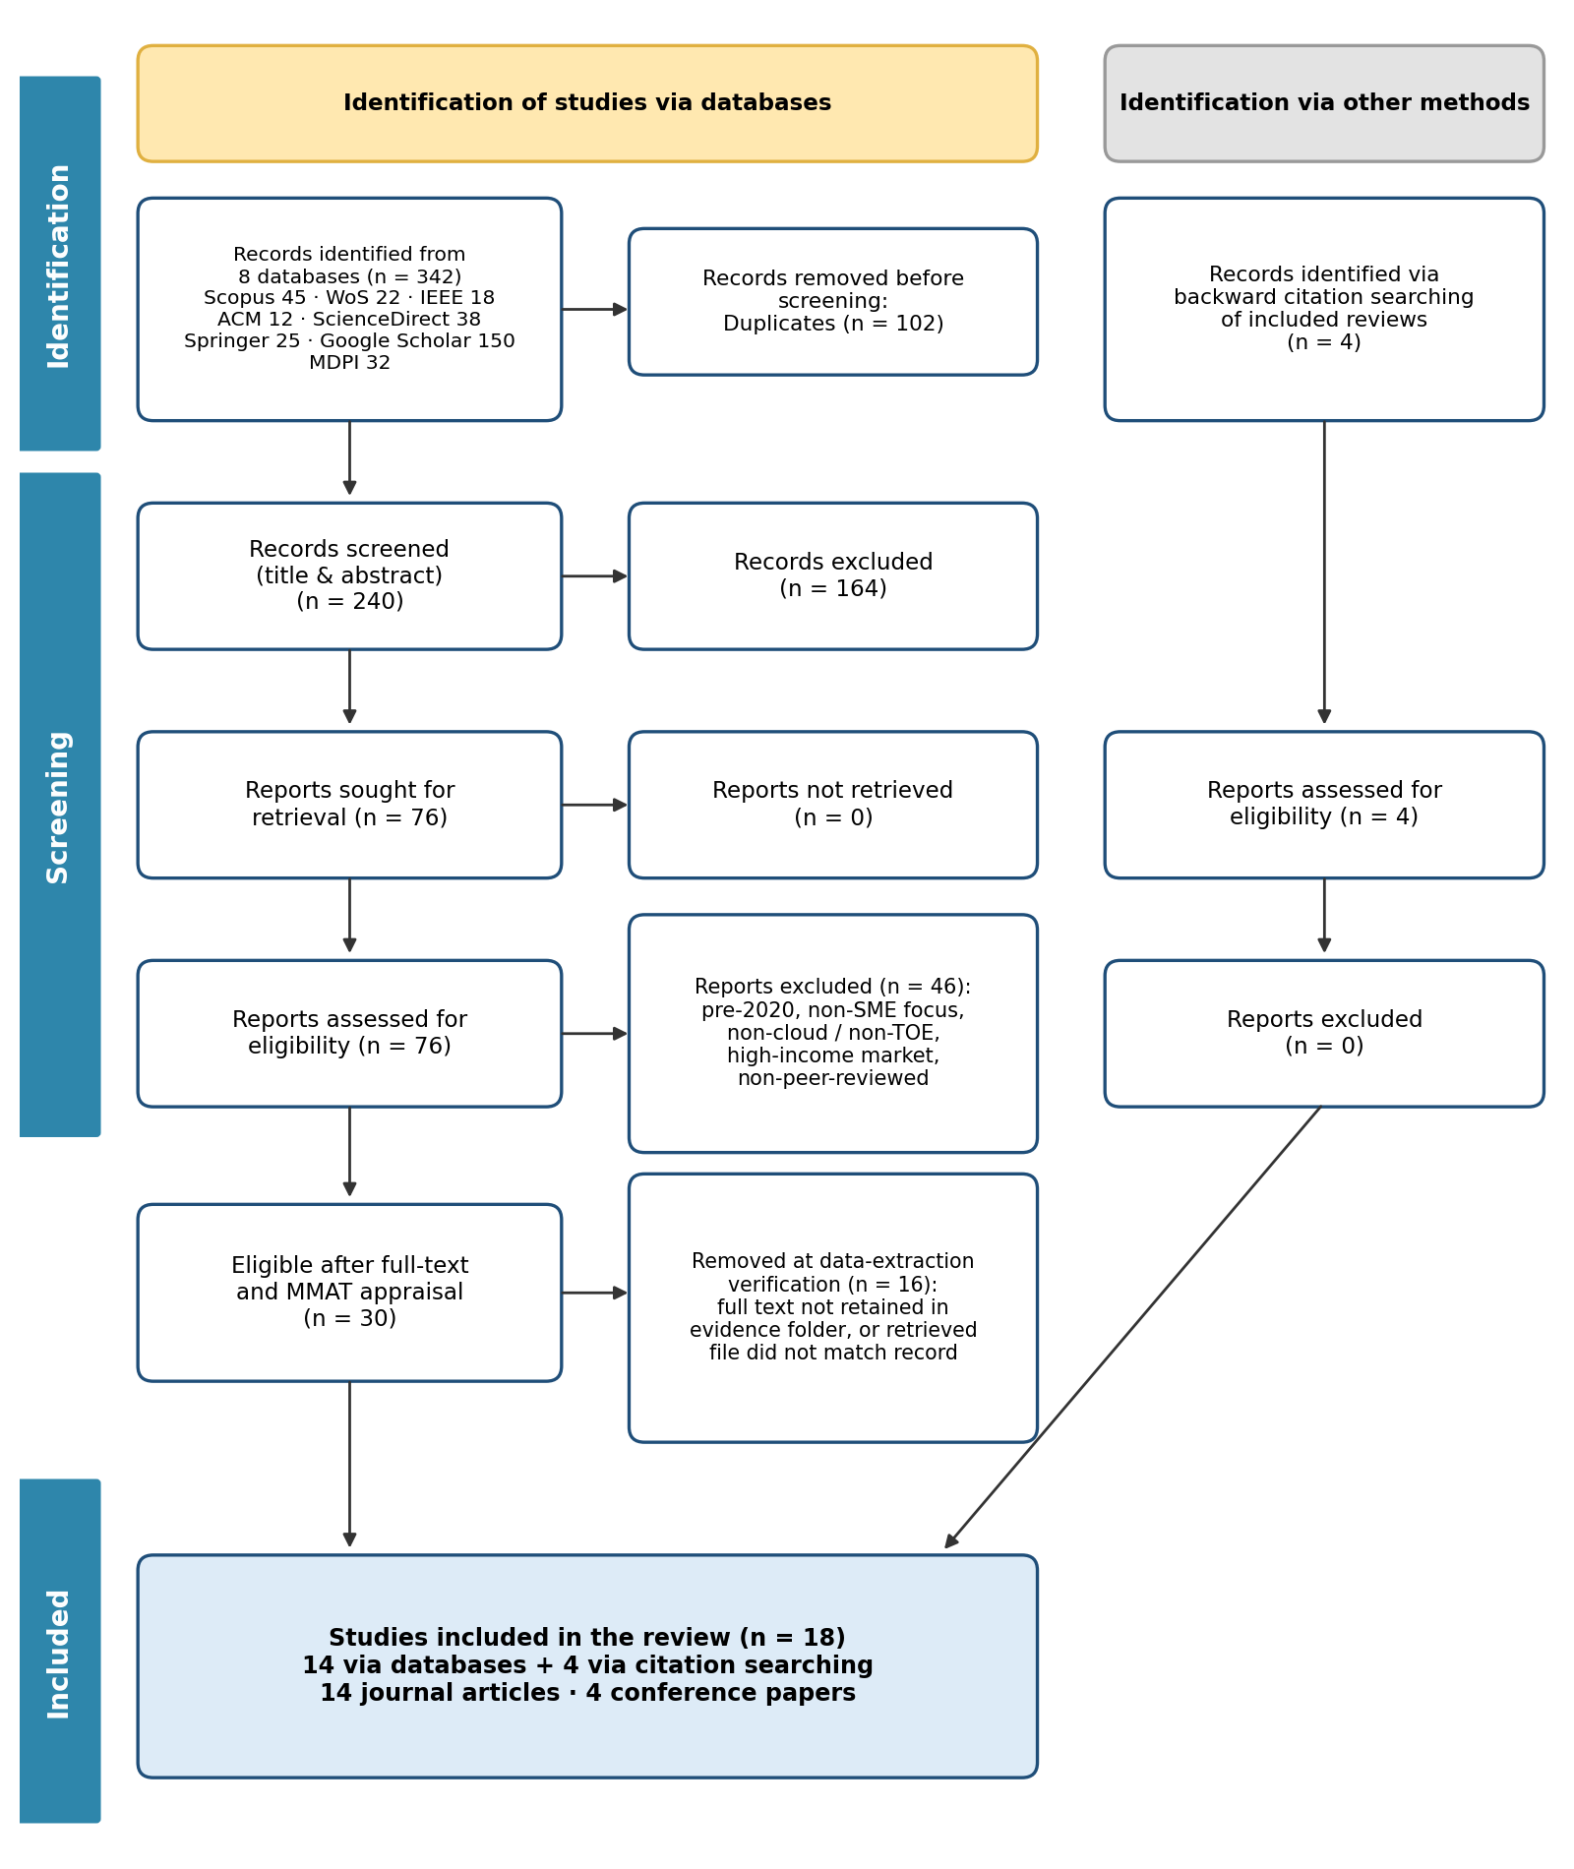
Figure 3.1: PRISMA 2020 flow diagram of the study selection process
Source: Adapted from Page et al. (2021) using the researcher's search log

3.7 Quality Appraisal
Each eligible study was appraised with the Mixed Methods Appraisal Tool (MMAT) version 2018 (Hong et al., 2018). Two screening questions (clarity of the research question and adequacy of the data) were followed by five design-specific criteria, each scored 1 for "Yes" and 0 for "No" or "Can't tell". Studies were rated High (4–5), Moderate (3) or Low (below 3). All 18 included studies were rated High (Appendix B), so no included study was weighted down in the synthesis.

3.8 Data Extraction
The researcher extracted data into a standardised matrix in the literature tracker. For each study the matrix recorded the bibliographic details, source database, publication channel, research method, country and sample, the TOE dimension addressed, the key finding with its page number, and whether POPIA or electricity reliability was discussed. To support the frequency analysis in Section 4.2.6, the full text of each study was also searched for terms linked to twelve TOE factors, and each hit was checked in context before a factor was recorded as discussed (at least three relevant mentions outside the reference list).

3.9 Data Analysis
The extracted data were analysed in two steps. First, the included studies were described by year, database, publication channel, research method and geographic focus, in the same way that the demographic profile of participants is reported in a survey. Second, the findings were analysed through the three-stage thematic synthesis of Thomas and Harden (2008): line-by-line coding of the findings, grouping of codes into descriptive themes, and interpretation of these into analytical themes. The coding was deductively anchored in the TOE framework but remained open to factors the framework does not anticipate, such as regulation and infrastructure reliability. The themes were then organised under the research question each one answers.

3.10 Rigour
Rigour was supported by a documented and repeatable search string, explicit inclusion criteria, a logged selection process, MMAT appraisal and verification of every extracted finding and page number against the source PDF. Where included studies disagreed, the disagreement was reported rather than resolved by selection.

3.11 Ethical Considerations
The study used only published, publicly available literature, and no human participants were involved. An ethics exemption was obtained from the CPUT departmental ethics committee. Ethical practice was maintained through accurate citation, plagiarism checking with SafeAssign, disclosure of AI tool use, and storage of all articles used as data for submission to Blackboard as the subject guide requires.

Chapter 4: Findings and Discussion

4.1 Introduction
This chapter presents the findings of the review. Section 4.2 describes the key attributes of the 18 included studies: their year, source database, publication channel, research method and geographic focus. Section 4.3 then presents the thematic analysis, organised by the four research questions raised in Chapter 1. Under each question, the themes that emerged from the literature are discussed by bringing the authors into conversation with one another and with the literature reviewed in Chapter 2.

4.2 Key Publication Attributes of the Included Studies
Table 4.1 lists the 18 included studies. Each study was given an ART code that is used throughout the analysis so that every finding can be traced back to its source.
Table 4.1: Summary of included studies
Code | Study | Context | Design and sample | Key finding
ART-001 | Aligarh, Sutopo & Widarjo (2023) | Indonesia | Quantitative survey, 197 MSME owners/managers; SEM-PLS | Relative advantage, organisational readiness, competitor pressure and bandwagon effect influence adoption
ART-002 | Abu Bakar et al. (2024) | Malaysia | Quantitative pilot survey; PLS-SEM | Extended TOE model; financial constraints and lack of digital culture hinder adoption
ART-003 | Al-Dwairi, Al-Tweit & Zyout (2018) | Jordan | Qualitative interviews, 16 e-commerce SME managers | Need, cost, security and reliability are the major factors
ART-004 | Mokwena & Fatoki (2024) | South Africa (Polokwane) | Quantitative survey, 106 of 230 SMEs responded | SMEs still use traditional IT; limited knowledge and security concerns are barriers
ART-005 | Mkhize et al. (2025) | Global review | SLR (PRISMA 2020), 90 of 18,570 studies | Cost savings 76%, management support 68%; initial cost 48% and security 45% as barriers
ART-008 | Sithole & Ruhode (2021) | South Africa | Quantitative online survey of SMME leaders | Relative advantage important; regulatory support a barrier; top management support not significant
ART-009 | Mhlongo et al. (2024) | Africa | Narrative review | Infrastructure, data security and skills gaps are challenges
ART-010 | Ilahi et al. (2024) | Global review | Literature review of TOE studies | Relative advantage, top management support, technical readiness, competitive pressure
ART-011 | Ahmad, Mahomed & Hashim (2025) | Global review | Bibliometric analysis, 662 Scopus articles | Rapid growth of SaaS/PaaS/IaaS research on SMEs
ART-012 | Jayeola et al. (2022) | Global review | SLR, 76 articles (2011–2020) | Cost savings most important factor; Asia most studied
ART-013 | Khayer et al. (2020) | Bangladesh | Quantitative survey, 372 SMEs; SEM (UTAUT + TOE) | Effort expectancy, security and privacy, trust and absorptive capacity predict adoption
ART-014 | Skafi, Yunis & Zekri (2020) | Lebanon | Quantitative survey, 139 respondents; logistic regression | Complexity, security, top management, prior IT experience; poor infrastructure and weak government negative
ART-015 | Shetty & Panda (2021) | Global review | Systematic and narrative review, 92 articles | Cost and flexibility central; policy an under-studied outlier
ART-017 | Salleh, Hussin & Suhaimi (2018) | Global review | SLR, 39 articles | Research concentrated on adoption; little on post-adoption impact
ART-018 | Nuskiya (2017) | Sri Lanka | Questionnaire and discussion, 50 enterprises | Top management support and technology readiness significant
ART-019 | Abubakar, Bass & Allison (2014) | Nigeria | Qualitative interviews, 10 SMEs | Adopters optimistic, less concerned with security; power issues
ART-021 | Modisane & Jokonya (2021) | South Africa | Quantitative survey; TOE constructs | TOE variables significantly affect likelihood of adoption; lack of ICT infrastructure and skills
ART-022 | Mohlameane & Ruxwana (2020) | South Africa | Multi-method (interviews, questionnaires, documents), 50 participants | No cloud-specific legislation; POPI Act only partly applicable

4.2.1 Publication representation by year
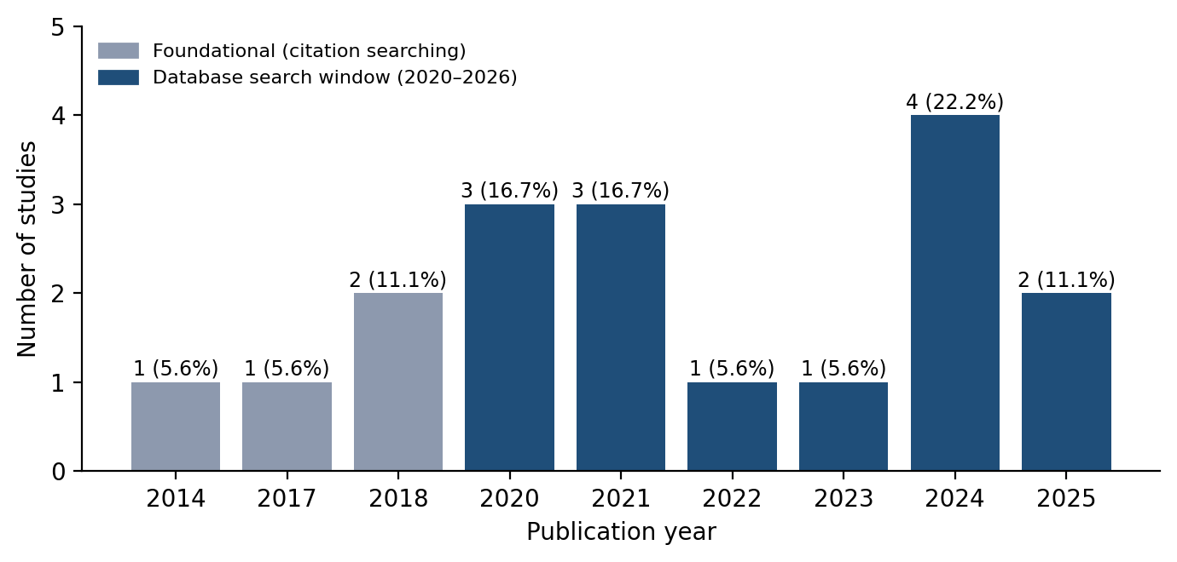
Figure 4.1: Distribution of included studies by publication year
Source: Researcher's analysis of included studies (n = 18)
Figure 4.1 shows that 14 of the 18 studies (77.8%) were published between 2020 and 2025, the window targeted by the database search. The largest group appeared in 2024 (4 studies, 22.2%), followed by 2020 and 2021 (3 studies each, 16.7%). This concentration reflects the growth of the field: Ahmad et al. (2025:1) found that SME cloud publications peaked at 140 articles in 2024. The four earlier studies (2014–2018), identified through citation searching, were retained because they provide foundational evidence on SMEs in sub-Saharan Africa and South Asia. The recent concentration means the findings reflect conditions after POPIA came into force, which is important for the regulatory analysis in Section 4.3.3.

4.2.2 Publication representation by database
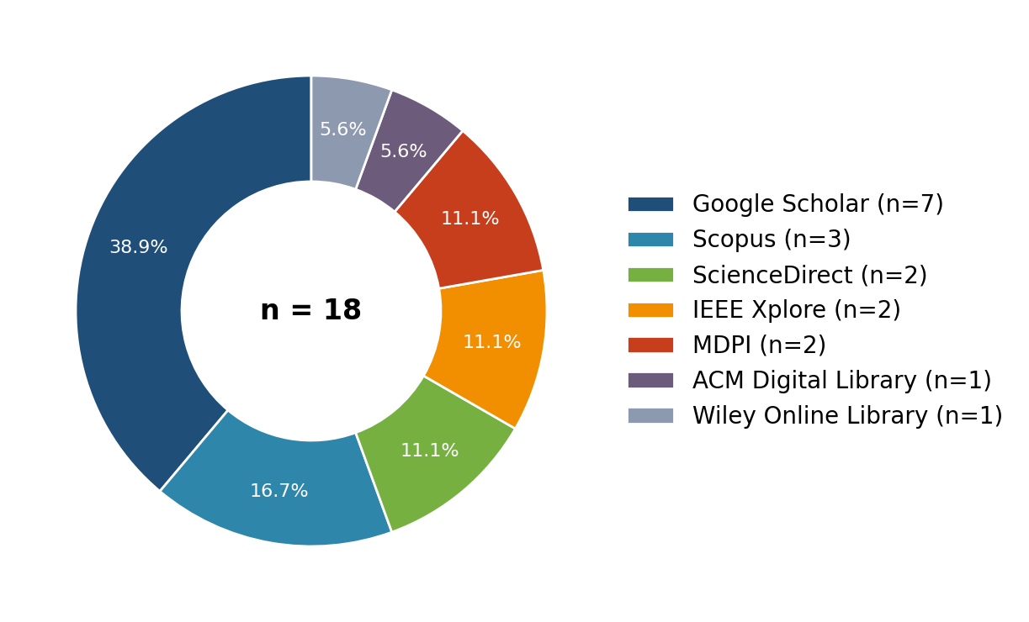
Figure 4.2: Distribution of included studies by source database
Source: Literature tracker, Source Database column (n = 18)
The included studies came from seven sources (Figure 4.2). Google Scholar contributed the most (7 studies, 38.9%), followed by Scopus (3, 16.7%) and ScienceDirect, IEEE Xplore and MDPI (2 each, 11.1%). ACM Digital Library and Wiley Online Library contributed one each (5.6%); the Wiley study (Abubakar et al., 2014) was found through citation searching. Google Scholar's large share is expected because it indexes regional and South African journals and conference proceedings that the subscription databases do not always cover. Three of the four South African studies came through Google Scholar, which shows that relying on subscription databases alone would have under-represented local evidence. Web of Science and SpringerLink returned records, but none of them survived eligibility assessment and verification.

4.2.3 Publication representation by channel
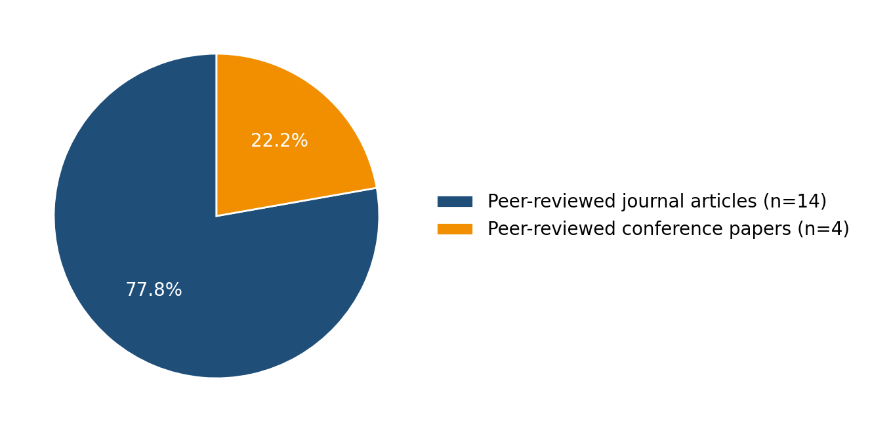
Figure 4.3: Distribution of included studies by publication channel
Source: Researcher's analysis of included studies (n = 18)
Figure 4.3 shows that 14 studies (77.8%) were peer-reviewed journal articles and 4 (22.2%) were peer-reviewed conference papers: Al-Dwairi et al. (2018) in the ACM ICIEB proceedings, Sithole and Ruhode (2021) in the IDIA proceedings, Salleh et al. (2018) in the IEEE ICT4M proceedings and Modisane and Jokonya (2021) in Procedia Computer Science. No theses, reports or non-peer-reviewed sources were included, in line with the exclusion criteria. The strong journal base supports the credibility of the synthesis.

4.2.4 Publication representation by research method
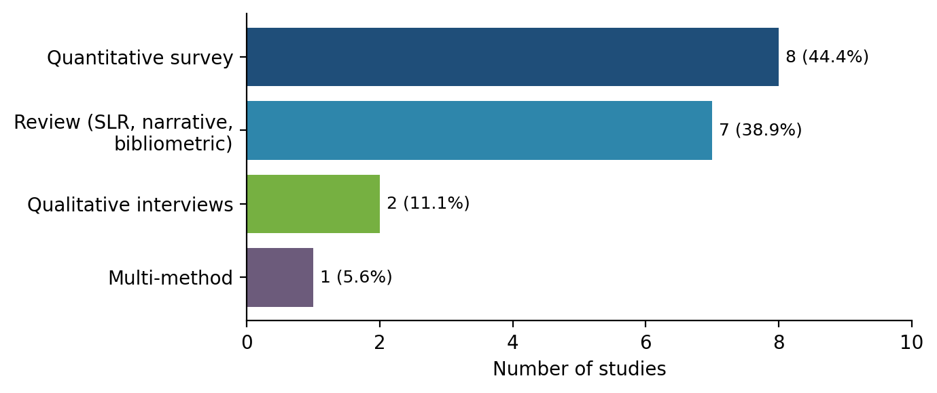
Figure 4.4: Distribution of included studies by research method
Source: Researcher's analysis of included studies (n = 18)
Quantitative surveys were the most common design (8 studies, 44.4%), usually testing TOE constructs with structural equation modelling or regression (Aligarh et al., 2023; Khayer et al., 2020; Skafi et al., 2020). Reviews formed the second group (7 studies, 38.9%): three systematic reviews (Jayeola et al., 2022; Mkhize et al., 2025; Salleh et al., 2018), a bibliometric study (Ahmad et al., 2025), a combined systematic and narrative review (Shetty & Panda, 2021) and two narrative reviews (Ilahi et al., 2024; Mhlongo et al., 2024). Only two studies used qualitative interviews (Abubakar et al., 2014; Al-Dwairi et al., 2018), and one used multiple methods (Mohlameane & Ruxwana, 2020). The review studies are valuable because each one synthesises many primary studies, which widens the evidence base considerably. The scarcity of qualitative work means that the reasons behind SME decisions, such as why owner-managers hesitate, are less well explained than the statistical relationships.

4.2.5 Publication representation by geographic focus
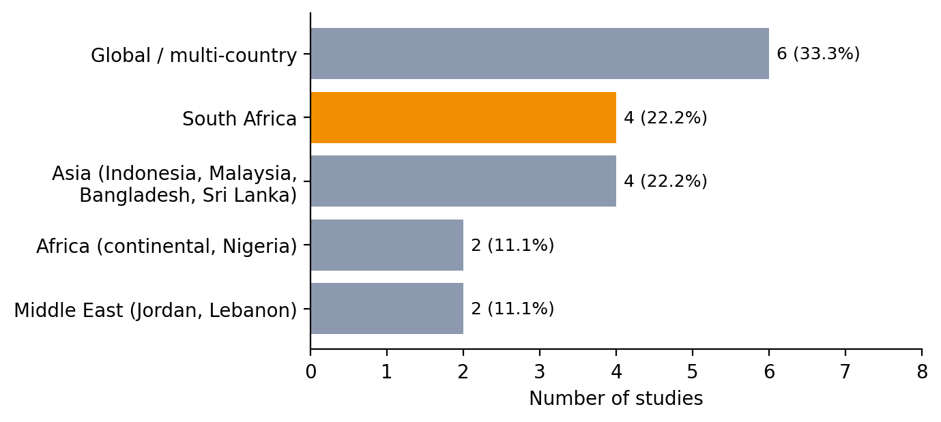
Figure 4.5: Distribution of included studies by geographic focus
Source: Researcher's analysis of included studies (n = 18)
Figure 4.5 shows a strong emphasis on developing economies. Global or multi-country reviews formed the largest group (6 studies, 33.3%). South Africa was the most represented single country, with four studies (22.2%): Sithole and Ruhode (2021), Mokwena and Fatoki (2024), Modisane and Jokonya (2021) and Mohlameane and Ruxwana (2020). Four studies came from Asia (22.2%), two from the rest of Africa (11.1%) and two from the Middle East (11.1%). Although South Africa is the best-represented country, four studies is a small base, which is why the review drew on comparable economies. Mkhize et al. (2025) was also written by South African researchers, although its scope is global.

4.2.6 Coverage of TOE factors
Table 4.2 shows which TOE contexts each study addressed, and Figure 4.6 shows how many studies discussed each factor.
Table 4.2: TOE context coverage by study (● substantial, ◐ partial)
Code | Technological | Organisational | Environmental | POPIA discussed | Electricity discussed
ART-001 | ● | ● | ● | No | No
ART-002 | ● | ● | ● | No | No
ART-003 | ● | ◐ | ◐ | No | No
ART-004 | ● | ● | ◐ | No | No
ART-005 | ● | ● | ● | No | No
ART-008 | ● | ● | ● | Yes | No
ART-009 | ● | ● | ● | No | No
ART-010 | ● | ● | ● | No | No
ART-011 | ● | ◐ | ◐ | No | No
ART-012 | ● | ● | ● | No | No
ART-013 | ● | ● | ◐ | No | No
ART-014 | ● | ● | ● | No | No
ART-015 | ● | ● | ● | No | No
ART-017 | ● | ◐ | ◐ | No | No
ART-018 | ● | ● | ◐ | No | No
ART-019 | ● | ● | ● | No | Yes
ART-021 | ● | ● | ● | Yes | No
ART-022 | ● | ◐ | ● | Yes | No

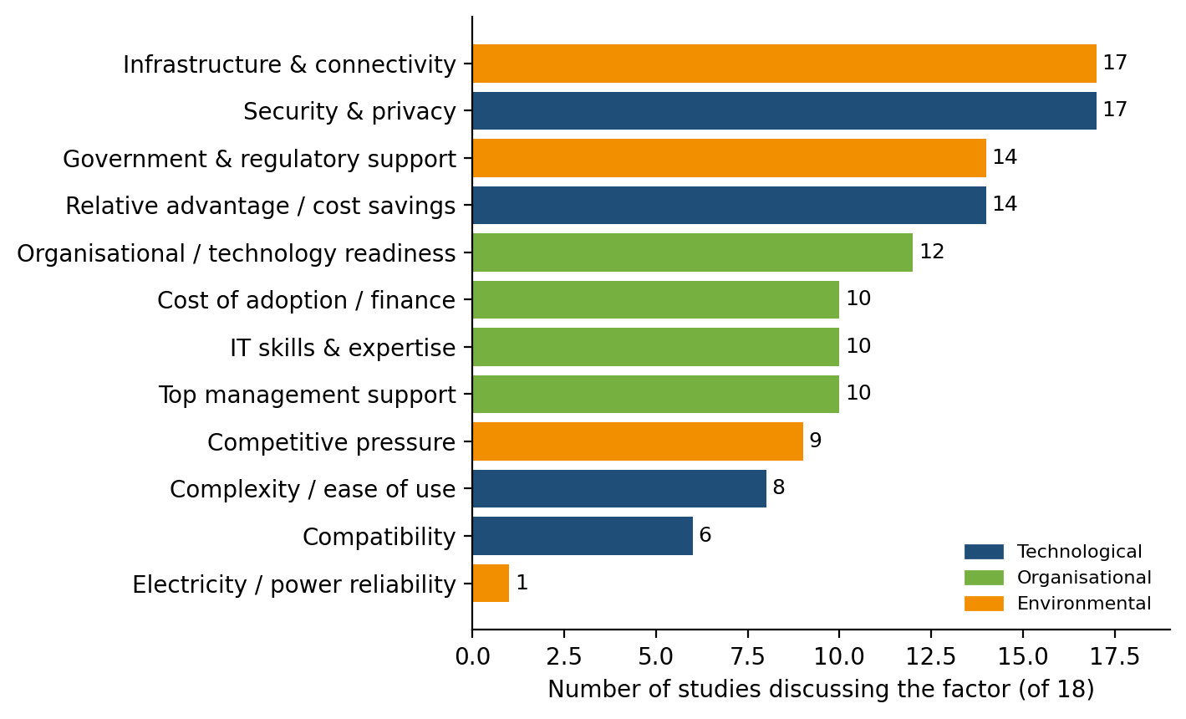
Figure 4.6: Frequency of TOE factors across the included studies
Source: Keyword-assisted coding of full texts, checked in context (n = 18)
Security and privacy, and infrastructure and connectivity, were each discussed in 17 of the 18 studies, followed by relative advantage and government or regulatory support (14 each). Organisational readiness (12), top management support, skills and adoption cost (10 each) formed a middle group. Compatibility (6) received the least attention among the standard TOE constructs. Only one study, Abubakar et al. (2014), discussed electricity reliability in any depth, and none examined South African load shedding directly. This gap is important and is revisited in Section 4.3.3.

4.3 Thematic Analysis
This section provides answers to the research questions raised in Chapter 1. The main research question asked what technological, organisational and environmental factors influence cloud adoption among South African SMEs, and how these factors can be addressed through a contextualised framework. Each sub-question is answered in turn. For each one, the themes that emerged from the included studies are discussed, and the authors' views are compared to show where they agree and where they differ. Table 4.3 summarises the links.
Table 4.3: Research questions, objectives and emergent themes
Research question | Objective | Emergent themes
RQ1: Technological factors | Objective 1 | Theme 1.1 Perceived value and relative advantage  Theme 1.2 Security, privacy and data sovereignty  Theme 1.3 Complexity and compatibility
RQ2: Organisational factors | Objective 2 | Theme 2.1 Owner-manager and top management support  Theme 2.2 Skills and IT expertise  Theme 2.3 Readiness and financial capacity
RQ3: Environmental factors | Objective 3 | Theme 3.1 Competitive pressure  Theme 3.2 Government and regulatory support  Theme 3.3 Infrastructure and power reliability
RQ4: Contextualised framework | Objective 4 | Relationships among Themes 1–3; contextualised TOE framework

4.3.1 Research Question 1: Technological Factors
RQ1: What technological factors hinder or enable cloud computing adoption among South African SMEs? This question aligns with Objective 1. In answering it, three themes emerged from the literature.

Theme 1.1: Perceived value and relative advantage
Relative advantage emerged as the most consistent enabler of adoption. Sithole and Ruhode (2021:282) found that relative advantage is an important factor for South African SMMEs considering the cloud. This was supported in Indonesia, where Aligarh et al. (2023:1) found that relative advantage significantly influenced adoption among 197 MSMEs, and in the review by Ilahi et al. (2024:55), which lists relative advantage among the four key determinants of adoption. The reviews quantify this pattern: Mkhize et al. (2025:1) report cost savings in 76% of the 90 studies they analysed and operational efficiency gains in 82%, and Jayeola et al. (2022:226) identify cost savings as the single most important adoption factor. Shetty and Panda (2021:1) likewise place cost and flexibility at the centre of the benefits of cloud computing.
The South African evidence adds an important condition. Mokwena and Fatoki (2024:4625, 4628) found that SMEs in Polokwane still rely on traditional IT services, and that limited knowledge of competitive IT solutions inhibits adoption. A benefit that is not known cannot drive a decision. This is consistent with Abubakar et al. (2014:9), who found that awareness among Nigerian owner-managers was a precondition for adoption. Relative advantage is therefore an enabler only when owner-managers are aware of it, which links this theme to the organisational context discussed under RQ2.

Theme 1.2: Security, privacy and data sovereignty
Security and privacy were discussed in 17 of the 18 studies, making them the most widely discussed factor in the review, which agrees with the finding of Jayeola et al. (2022:234) that security and privacy are the most researched factors in the field. Mokwena and Fatoki (2024:4628) identified security as the greatest barrier to cloud adoption among Polokwane SMEs, and Mkhize et al. (2025:1) report that data security risks affected 45% of the SMEs in their review. In Bangladesh, Khayer et al. (2020:64) found data security and privacy, together with perceived trust, to be significant predictors of adoption, and in Jordan, Al-Dwairi et al. (2018:1) named security among the four major factors.
The evidence is not uniform, however. Abubakar et al. (2014:1) found that Nigerian SMEs that had already adopted the cloud were less concerned with security and privacy than the literature from the global north suggests. This suggests that security concern is strongest before adoption and may fall once firms gain experience.
In South Africa, security concerns are reinforced by regulation. Mohlameane and Ruxwana (2020:5–7) found that there is no dedicated legislative framework for cloud computing, that there is a lack of clarity on how the POPI Act applies to cross-border data transfers, and that some of its provisions apply only partly to cloud services. Only three of the included studies discussed POPIA at all (Table 4.2). This study interprets the resulting uncertainty as sovereignty friction: without legal guidance, an SME storing customer data with an international provider cannot be sure it is compliant, and may treat that uncertainty as a reason to delay.

Theme 1.3: Complexity and compatibility
Complexity and compatibility were discussed less often (8 and 6 studies respectively), but where they were measured they mattered. Skafi et al. (2020:79169) found complexity and security to be significantly related to the adoption decision in Lebanon, and Khayer et al. (2020:64) found that effort expectancy, the perceived ease of using the cloud, fell in the critical zone that most needed improvement. Jayeola et al. (2022:239) found compatibility significant in 79.3% of the studies they reviewed, and Mkhize et al. (2025:2) list perceived complexity among the main obstacles. Complexity depends on the service model: Ahmad et al. (2025:2) distinguish SaaS, PaaS and IaaS, and only SaaS removes the need to manage infrastructure. For SMEs without IT staff, the technological barrier is therefore lowest when adoption starts with SaaS.
Answer to RQ1. Relative advantage, especially cost saving, is the main technological enabler, but only when owner-managers are aware of it. Security and privacy concerns are the main technological inhibitor, and in South Africa they are intensified by uncertainty over how POPIA applies to cloud data. Complexity and compatibility are secondary barriers that can be reduced by choosing simpler service models.

4.3.2 Research Question 2: Organisational Factors
RQ2: What organisational factors influence the cloud computing adoption decisions of South African SMEs? This question aligns with Objective 2. Three themes emerged.

Theme 2.1: Owner-manager and top management support
Top management support was discussed in 10 studies, and on this theme the literature diverges. The international evidence treats it as a leading driver: it was significant in 82.1% of the studies reviewed by Jayeola et al. (2022:239), cited as a driver by 68% of those reviewed by Mkhize et al. (2025:1), and listed among the key determinants by Ilahi et al. (2024:55). Primary studies agree: Skafi et al. (2020:79169) and Nuskiya (2017:1) both found top management support to be significant.
Sithole and Ruhode (2021:282, 288) found the opposite in South Africa: top management support was not significantly related to adoption opportunities (χ² = 1.728, p = 0.189). Their study measured management support through access to finance, which may explain the difference. The divergence suggests that in small South African firms, where the owner-manager makes the decision, willingness alone is not enough. Support leads to adoption only when it comes with the knowledge and resources to act on it, which is consistent with the awareness finding under Theme 1.1 (Mokwena & Fatoki, 2024:4628; Abubakar et al., 2014:9).

Theme 2.2: Skills and IT expertise
Skills were discussed in 10 studies and appeared consistently as a barrier. Mhlongo et al. (2024:1446) report that digital literacy and technical skills are lacking among African SMEs, and Modisane and Jokonya (2021:784) identify the lack of ICT skills as part of the general lack of resource capability facing South African SMMEs. Mkhize et al. (2025:2) list the absence of prior IT experience among the main obstacles. Conversely, where skills were present they enabled adoption: Skafi et al. (2020:79169) found prior IT experience positively related to the adoption decision, and Khayer et al. (2020:64) found absorptive capacity, the firm's ability to absorb new knowledge, to be a significant predictor. Skills therefore affect adoption in both directions: firms that lack them delay, and firms that have them adopt.

Theme 2.3: Readiness and financial capacity
Organisational readiness (12 studies) and adoption cost (10 studies) form the third theme. Aligarh et al. (2023:1) found organisational readiness significant, and Nuskiya (2017:1) found technology readiness significant in Sri Lanka. Ilahi et al. (2024:55) list technical readiness among the four key determinants. Cost is two-sided. Cloud computing removes the need for capital investment in hardware (Shetty & Panda, 2021:1), yet initial cost concerns affected 48% of SMEs in the studies reviewed by Mkhize et al. (2025:1), and Abu Bakar et al. (2024:554) identify financial constraints and maintenance costs as challenges. Mokwena and Fatoki (2024:4625) also link SME failure to the non-availability of financial and IT resources. The shift from capital to operational expenditure is therefore attractive in principle, but only to firms that can budget for ongoing subscriptions, connectivity and support.
Answer to RQ2. Adoption depends on the owner-manager's knowledge and disposition, the skills available to the firm, and its financial readiness. The South African evidence shows that management support in principle does not lead to adoption unless it is backed by knowledge and resources, and the skills deficit is the most consistent organisational barrier.

4.3.3 Research Question 3: Environmental Factors
RQ3: What environmental factors shape SME decisions to adopt or avoid cloud-based systems in South Africa? This question aligns with Objective 3. Three themes emerged.

Theme 3.1: Competitive pressure
Competitive pressure was discussed in 9 studies and acts as an external push. Aligarh et al. (2023:1) found competitor pressure and the bandwagon effect significant, and Ilahi et al. (2024:55) list competitive pressure among the key determinants. Sithole and Ruhode (2021:285, 287) tested competitive and trading-partner pressure as environmental constructs in South Africa. Competitive pressure is, however, a weaker theme than the constraints discussed below, because none of the South African studies found it to be the dominant factor.

Theme 3.2: Government and regulatory support
Government and regulatory support was discussed in 14 studies and emerged mainly as a constraint. Sithole and Ruhode (2021:282) found that South African SMMEs perceive government and regulatory support as a barrier rather than an enabler. Mohlameane and Ruxwana (2020:5–7) explain part of the reason: South Africa has no cloud-specific legislative framework, and existing laws, including the POPI Act, fit cloud computing only partly. The same pattern appears elsewhere: Skafi et al. (2020:79169) found a lack of government initiatives negatively related to adoption in Lebanon. Shetty and Panda (2021:1) identify policy as an under-researched outlier in the literature, and Mhlongo et al. (2024:1444) call for government policies and infrastructure investment to support SME adoption in Africa. Support that is absent or unclear therefore weakens the push that competition creates.

Theme 3.3: Infrastructure and power reliability
Infrastructure and connectivity were discussed in 17 studies. Mhlongo et al. (2024:1445–1446) identify limited internet infrastructure and low rural broadband penetration as barriers across Africa, Modisane and Jokonya (2021:784) cite the lack of ICT infrastructure among South African SMMEs, and Skafi et al. (2020:79169) found poor infrastructure negatively related to adoption.
Electricity reliability, however, is the least evidenced factor in the review. Only Abubakar et al. (2014:7, 9–10) discussed it in depth. They found that Nigerian SMEs used cloud back-ups because of power problems, and that the cloud partly offset the cost of running electricity-hungry hardware on site. This suggests that unreliable power can work in two directions: it can deter adoption by threatening access, and it can encourage adoption by removing local hardware. None of the included studies measured the effect of South African load shedding on cloud use. This is therefore reported as an evidence gap rather than an established finding, and the framework treats it as a condition to be tested.
Answer to RQ3. Competitive pressure encourages adoption, but perceived weak government support, regulatory uncertainty and inadequate infrastructure constrain it. The evidence on electricity reliability is thin and inconclusive for South Africa.

4.3.4 Research Question 4: A Contextualised Framework
RQ4: How can a TOE-informed framework guide South African SMEs to adopt cloud computing in an affordable, compliant and operationally appropriate way? This question aligns with Objective 4 and draws on the relationships among the themes.
Read together, the themes show that the three contexts are linked. Regulatory uncertainty (Theme 1.2) reinforces owner-manager caution (Theme 2.1), and weak government support and infrastructure (Themes 3.2 and 3.3) leave that caution unchallenged. Low awareness (Theme 1.1) and the skills deficit (Theme 2.2) mean that the cost advantage documented in the reviews is not recognised. A framework that lists these factors separately would miss these links. The proposed framework (Figure 4.7) therefore adds a South African context layer (POPIA uncertainty, electricity and connectivity reliability, and owner-manager awareness) above the three standard contexts, and links each context to a practical response (Table 4.4).
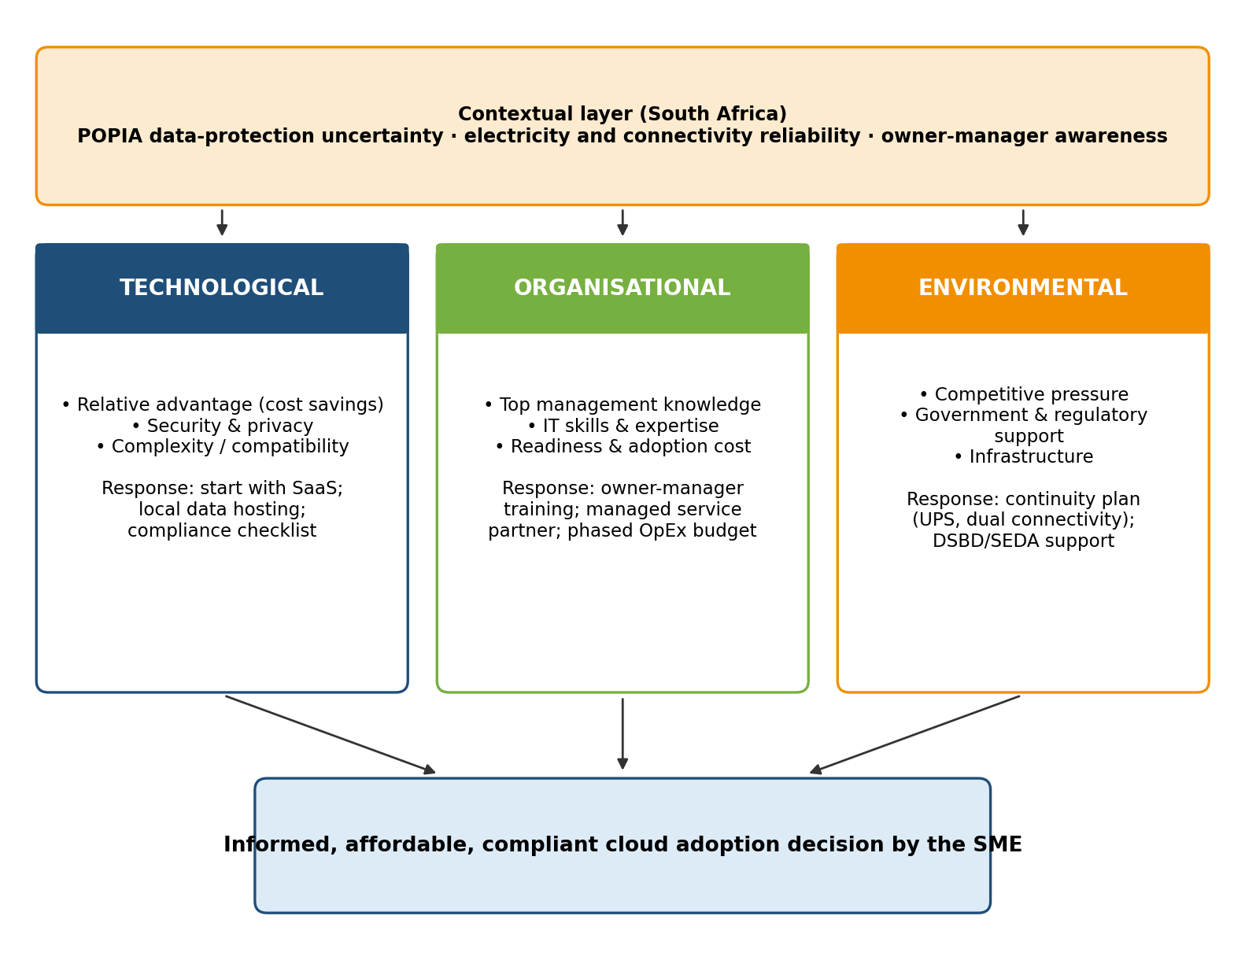
Figure 4.7: Proposed contextualised TOE framework for South African SMEs
Source: Researcher's synthesis of Themes 1.1–3.3
Table 4.4: Contextualised TOE framework matrix
TOE context | Evidence from the review | South African constraint | Proposed response (researcher's proposal)
Technological | Relative advantage (14 studies); security and privacy (17) | POPIA fits cloud only partly; low awareness of benefits | Start with SaaS; prefer locally hosted data centres for personal data; obtain compliance guidance before migration
Organisational | Top management support (10); skills (10); readiness (12) | Owner-manager decides alone; skills deficit; cash constraints | Owner-manager awareness training; managed service partner; phased operational budget
Environmental | Government support (14); infrastructure (17); competitive pressure (9) | Weak perceived support; rural connectivity; electricity reliability untested | Continuity plan (UPS, dual connectivity) for critical systems; DSBD and SEDA digital support programmes
Context layer | POPIA in 3 studies; electricity in 1 | Evidence gap on local regulation and power | Treat as conditions to assess before adoption and to test in future research

The responses in the final column are the researcher's proposals derived from the themes; they are not findings reported by the included studies. The framework is intended as a decision aid that shows SME owners where their readiness is weakest, not as a model that predicts adoption. It has not been empirically validated.

4.4 Discussion of Findings Against the Literature
The findings confirm the TOE premise that adoption results from the interaction of technological, organisational and environmental contexts (Tornatzky & Fleischer, 1990). They agree with the international literature that relative advantage and security are the most prominent technological factors (Jayeola et al., 2022; Mkhize et al., 2025). They depart from it in two respects. First, top management support, a leading driver internationally, was not significant in the South African survey evidence (Sithole & Ruhode, 2021), which suggests that the construct needs to be measured as knowledgeable support rather than as willingness or finance. Second, the environmental context in South Africa is dominated by constraints (unclear regulation and weak infrastructure) rather than by the competitive push emphasised in Asian studies (Aligarh et al., 2023). These differences justify a contextualised framework rather than direct application of models developed elsewhere.

Chapter 5: Conclusion and Recommendations

5.1 Summary of the Study
This study adopted a qualitative systematic literature review to examine why cloud computing adoption among South African SMEs remains limited. Following PRISMA 2020, the researcher identified 342 records from eight databases, screened and appraised them, and included 18 verified studies. The studies were profiled by year, database, channel, method and geography, and their findings were synthesised thematically through the TOE framework.

5.2 Answers to the Research Questions
- RQ1 (Technological). Relative advantage is the main enabler but depends on awareness; security and privacy, intensified by POPIA uncertainty, are the main inhibitors; complexity and compatibility are secondary barriers.
- RQ2 (Organisational). Adoption depends on owner-manager knowledge, available skills and financial readiness. Management support alone does not ensure adoption in South Africa.
- RQ3 (Environmental). Competitive pressure encourages adoption, while weak government support, regulatory uncertainty and inadequate infrastructure constrain it. Evidence on electricity reliability is scarce.
- RQ4 (Framework). A contextualised TOE framework adds a South African context layer and links each context to practical responses.
Together these answers address the main research question: cloud adoption among South African SMEs is shaped less by the technology itself than by awareness, skills, regulatory clarity and infrastructure, and these factors must be addressed together.

5.3 Recommendations
- For SME owner-managers: begin with low-complexity SaaS applications; choose providers with local data hosting for personal information; obtain POPIA compliance guidance before migrating; and plan fallback access for critical systems.
- For cloud and managed service providers: offer transparent, fixed-price contracts in rand, and position managed services as a way to close the skills gap that small firms report.
- For policy makers (DSBD, SEDA and the Information Regulator): provide digital literacy programmes for owner-managers, and publish plain-language guidance on how POPIA applies to cloud services.

5.4 Contribution of the Study
Theoretically, the study extends the TOE framework to the South African SME context by adding a context layer covering regulation, infrastructure reliability and owner-manager awareness. Practically, it gives SME owners, providers and policy makers a structured tool for identifying where adoption support is most needed.

5.5 Limitations
The study relied on secondary data, so its findings depend on the scope and quality of the 18 included studies. Only four studies examined South Africa directly, and only one discussed electricity reliability in depth. Sixteen eligible records were removed at verification because their full texts were not available, which may have narrowed the evidence base. The factor frequencies in Figure 4.6 indicate how often a factor was discussed, not its statistical strength. The framework has not been tested with SMEs.

5.6 Future Research
Future research should validate the framework through surveys or case studies of South African SMEs, measure directly how load shedding and connectivity disruptions affect cloud use, and examine how SMEs interpret POPIA when choosing cloud providers. Qualitative interviews with owner-managers would help explain why management support does not always lead to adoption.

References
Abu Bakar, M.R., Mat Razali, N.A., Ishak, K.K., Ismail, M.N. & Tengku Sembok, T.M. 2024. Adoption of Industry 4.0 with cloud computing as a mediator: evaluation using TOE framework for SMEs. JOIV: International Journal on Informatics Visualization, 8(2):554–563.
Abubakar, A.D., Bass, J.M. & Allison, I. 2014. Cloud computing: adoption issues for sub-Saharan African SMEs. The Electronic Journal of Information Systems in Developing Countries, 62(1):1–17.
Ahmad, C.S., Mahomed, A.S.B. & Hashim, H. 2025. Cloud computing adoption in SMEs: exploring IaaS, PaaS and SaaS through a bibliometric study. International Journal of Academic Research in Business and Social Sciences, 15(1). http://dx.doi.org/10.6007/IJARBSS/v15-i1/24452
Al-Dwairi, R.M., Al-Tweit, N. & Zyout, K. 2018. Factors influencing cloud-computing adoption in small and medium e-commerce enterprises in Jordan. In Proceedings of the International Conference on Industrial Engineering and Business (ICIEB 2018), Singapore, 25–27 April 2018. New York: ACM.
Aligarh, F., Sutopo, B. & Widarjo, W. 2023. The antecedents of cloud computing adoption and its consequences for MSMEs' performance: a model based on the Technology-Organization-Environment (TOE) framework. Cogent Business & Management, 10(2): Article 2220190. https://doi.org/10.1080/23311975.2023.2220190
Davis, F.D. 1989. Perceived usefulness, perceived ease of use, and user acceptance of information technology. MIS Quarterly, 13(3):319–340.
Hong, Q.N., Fàbregues, S., Bartlett, G., Boardman, F., Cargo, M., Dagenais, P., Gagnon, M.-P., Griffiths, F., Nicolau, B., O'Cathain, A., Rousseau, M.-C., Vedel, I. & Pluye, P. 2018. The Mixed Methods Appraisal Tool (MMAT) version 2018 for information professionals and researchers. Education for Information, 34(4):285–291.
Ilahi, S., Mohammed, R., Souissi, A., Hamati, M.Y.N. & Smida, R. 2024. Small and medium enterprises (SMEs): key factors affecting the adoption of cloud computing. Saudi Journal of Humanities and Social Sciences, 9(2):55–62. https://doi.org/10.36348/sjhss.2024.v09i02.004
Jayeola, O., Sidek, S., Abd Rahman, A., Mahomed, A.S.B. & Hu, J. 2022. Cloud computing adoption in small and medium enterprises (SMEs): a systematic literature review and directions for future research. International Journal of Business and Society, 23(1):226–243. https://doi.org/10.33736/ijbs.4610.2022
Khayer, A., Jahan, N., Hossain, M.N. & Hossain, M.Y. 2020. The adoption of cloud computing in small and medium enterprises: a developing country perspective. VINE Journal of Information and Knowledge Management Systems, 51(1):64–91 (published online 2020).
Mell, P. & Grance, T. 2011. The NIST definition of cloud computing. NIST Special Publication 800-145. Gaithersburg: National Institute of Standards and Technology.
Mhlongo, N.Z., Usman, F.O., Odeyemi, O., Ike, C.U., Elufioye, O.A. & Daraojimba, A.I. 2024. Reviewing the impact of cloud computing on small and medium enterprises in Africa. International Journal of Science and Research Archive, 11(1):1444–1451. https://doi.org/10.30574/ijsra.2024.11.1.0236
Mkhize, A., Mokhothu, K.D., Tshikhotho, M. & Thango, B.A. 2025. Evaluating the impact of cloud computing on SME performance: a systematic review. Businesses, 5(2): Article 23. https://doi.org/10.3390/businesses5020023
Modisane, P. & Jokonya, O. 2021. Evaluating the benefits of cloud computing in small, medium and micro-sized enterprises (SMMEs). Procedia Computer Science, 181:784–792.
Mohlameane, M. & Ruxwana, N. 2020. Exploring the impact of cloud computing on existing South African regulatory frameworks. South African Journal of Information Management, 22(1): a1132. https://doi.org/10.4102/sajim.v22i1.1132
Mokwena, J.H. & Fatoki, O. 2024. Barriers of cloud computing adoption by small and medium enterprises in Polokwane Municipality. Tuijin Jishu/Journal of Propulsion Technology, 45(2):4625–4634.
Nuskiya, A.F. 2017. Factors influencing cloud computing adoption by SMEs in eastern region of Sri Lanka. Journal of Information Systems & Information Technology, 2(1).
Page, M.J., McKenzie, J.E., Bossuyt, P.M., Boutron, I., Hoffmann, T.C., Mulrow, C.D. et al. 2021. The PRISMA 2020 statement: an updated guideline for reporting systematic reviews. BMJ, 372: n71. https://doi.org/10.1136/bmj.n71
Salleh, N.A., Hussin, H. & Suhaimi, M.A. 2018. A systematic literature review of cloud computing adoption and impacts among small medium enterprises (SMEs). In 2018 International Conference on Information and Communication Technology for the Muslim World (ICT4M). Kuala Lumpur: IEEE.
Shetty, J.P. & Panda, R. 2021. An overview of cloud computing in SMEs. Journal of Global Entrepreneurship Research. https://doi.org/10.1007/s40497-021-00273-2
Sithole, S.S. & Ruhode, E. 2021. Cloud computing adoption: opportunities and challenges for small, medium and micro enterprises in South Africa. In Proceedings of the 1st Virtual Conference on Implications of Information and Digital Technologies for Development, 282–301.
Skafi, M., Yunis, M.M. & Zekri, A. 2020. Factors influencing SMEs' adoption of cloud computing services in Lebanon: an empirical analysis using TOE and contextual theory. IEEE Access, 8:79169–79181. https://doi.org/10.1109/ACCESS.2020.2987331
Thomas, J. & Harden, A. 2008. Methods for the thematic synthesis of qualitative research in systematic reviews. BMC Medical Research Methodology, 8: 45. https://doi.org/10.1186/1471-2288-8-45
Tornatzky, L.G. & Fleischer, M. 1990. The processes of technological innovation. Lexington, MA: Lexington Books.
Tranfield, D., Denyer, D. & Smart, P. 2003. Towards a methodology for developing evidence-informed management knowledge by means of systematic review. British Journal of Management, 14(3):207–222.

Appendix A: Data Extraction Summary
Code | TOE dimension | Key extracted finding | Page | Answers
ART-001 | T, O, E | Relative advantage, organisational readiness, competitor pressure significant | PDF p.1 | RQ1–3
ART-002 | O, E | Financial constraints, maintenance cost, lack of digital culture | p.554 | RQ2
ART-003 | T | Need, cost, security and reliability major factors | PDF p.1 | RQ1
ART-004 | T, O | Traditional IT still used; limited knowledge; security the greatest barrier | pp.4625, 4628 | RQ1–2
ART-005 | T, O | Cost savings 76%; management support 68%; initial cost 48%; security 45% | p.1 | RQ1–2
ART-008 | T, O, E | Relative advantage important; regulatory support a barrier; TMS not significant (p = 0.189) | pp.282, 288 | RQ1–3
ART-009 | O, E | Infrastructure, security and skills gaps; rural broadband limited | pp.1445–1446 | RQ2–3
ART-010 | T, O, E | Relative advantage, TMS, technical readiness, competitive pressure | p.55 | RQ1–3
ART-011 | T | Service models IaaS, PaaS, SaaS; research peak in 2024 | PDF pp.1–2 | RQ1
ART-012 | T, O | Cost savings most important; compatibility 79.3%; TMS 82.1% | pp.226, 239 | RQ1–2
ART-013 | T, O | Effort expectancy, security and privacy, trust, absorptive capacity | p.64 | RQ1–2
ART-014 | T, O, E | Complexity, security, TMS, prior IT experience; poor infrastructure negative | p.79169 | RQ1–3
ART-015 | T, E | Cost and flexibility central; policy an outlier | p.1 | RQ1, RQ3
ART-017 | T | Research focused on adoption; post-adoption under-studied | PDF p.1 | RQ1
ART-018 | O | Top management support and technology readiness significant | p.1 | RQ2
ART-019 | O, E | Awareness needed; low security concern; power issues and cloud back-ups | pp.1, 7, 9–10 | RQ2–3
ART-021 | O, E | Lack of ICT infrastructure and skills; TOE variables affect adoption | p.784 | RQ2–3
ART-022 | E | No cloud-specific legislation; POPI Act partly applies | pp.5–7 | RQ1, RQ3

Appendix B: MMAT Quality Appraisal
All included studies were rated High (4–5 of 5 criteria met). Source: Article Screening & MMAT sheet of the literature tracker.
Code | Study | MMAT score | Rating
ART-001 | Aligarh et al. (2023) | 5 | High
ART-002 | Abu Bakar et al. (2024) | 5 | High
ART-003 | Al-Dwairi et al. (2018) | 4 | High
ART-004 | Mokwena & Fatoki (2024) | 5 | High
ART-005 | Mkhize et al. (2025) | 5 | High
ART-008 | Sithole & Ruhode (2021) | 5 | High
ART-009 | Mhlongo et al. (2024) | 5 | High
ART-010 | Ilahi et al. (2024) | 5 | High
ART-011 | Ahmad et al. (2025) | 5 | High
ART-012 | Jayeola et al. (2022) | 5 | High
ART-013 | Khayer et al. (2020) | 5 | High
ART-014 | Skafi et al. (2020) | 5 | High
ART-015 | Shetty & Panda (2021) | 5 | High
ART-017 | Salleh et al. (2018) | 5 | High
ART-018 | Nuskiya (2017) | 5 | High
ART-019 | Abubakar et al. (2014) | 5 | High
ART-021 | Modisane & Jokonya (2021) | 5 | High
ART-022 | Mohlameane & Ruxwana (2020) | 5 | High

Appendix C: Database Search Strings
Database | Search string
Scopus / Google Scholar | ("cloud computing adoption" OR "cloud adoption") AND ("SMEs" OR "small and medium enterprises" OR "SMMEs") AND ("TOE" OR "Technology Organisation Environment")
Web of Science | ("cloud computing adoption" OR "cloud adoption") AND ("SMEs" OR "small and medium enterprises") AND ("TOE framework")
IEEE Xplore | ("cloud adoption") AND ("SME" OR "small enterprise") AND ("TOE") AND ("South Africa")
ACM Digital Library | ("cloud computing adoption") AND ("SMEs") AND ("TOE") AND ("developing economy")
ScienceDirect | ("cloud adoption") AND ("SMEs") AND ("TOE framework") AND ("developing economy")
SpringerLink | ("cloud computing adoption") AND ("SMEs") AND ("Technology Organisation Environment") AND ("South Africa")
MDPI | ("cloud adoption" OR "cloud computing adoption") AND ("SMEs" OR "small business") AND ("TOE framework") AND ("South Africa")

